#SustainableBelgium

Sustainable Belgium, the crucial next decade

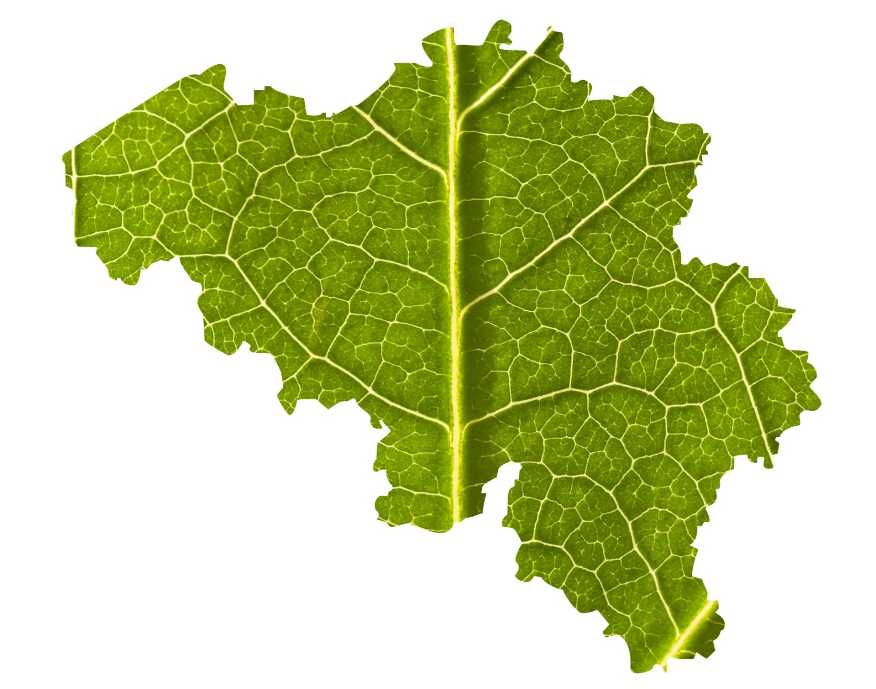
31 March 2021

#SustainableBelgium
#SustainableBelgium

The OECD will publish its report on Belgium's Environmental Performance Review on 31 March. All regional and federal administrations were involved in answering the reviewers' questions. More than 250 Belgian experts took part in this exercise.
This Belgian Environmental Performance Review (EPR) is a recurring cycle of analysis and exchange between the OECD and the Belgian authorities. It last took place in 2007. The new report therefore takes stock of the policies pursued in Belgium over the past 13 years. It covers the themes of water and air quality, waste and the circular economy, biodiversity, climate change, sustainable development and green growth, compliance with legislation, and governance (access to information and justice for citizens), as well as the coordination of the environmental policies led by the Regions and the Federal Government.

Water quality
In its report, the OECD points out that Belgium has a long way to go to achieve the "good status" for water bodies objective of the EU Water Framework Directive. The high use of nutrients and pesticides in agriculture are the most significant sources of surface and groundwater pollution.
The OECD recommends that Belgium continue to improve water quality monitoring to assess the status of water bodies in accordance with the Water Framework Directive and identify key measures to address priority substances. These recommendations are timely, as drafts of the third International River Basin Management Plans (2022-2027) are currently being prepared. In the plans, each region addresses adaptation to climate change, for example by systematically tackling the problem of drought. In July 2020, the Flemish government also launched a Blue Deal, an ambitious plan containing more than 70 actions to structurally address the drought issue using six different approaches. This Blue Deal definitely moves Flanders towards greater recovery and water buffering, the restoration and enhancement of wetlands and the maximum circular use of water. As well as tackling the problem of drought, the Blue Deal is also beneficial for water quality. In Wallonia, emerging substances are currently being monitored. They have already been the subject of three projects, mainly related to drugs and endocrine disruptors, and two new projects are underway, linked to the cocktail effect and the impact of certain emerging substances on aquatic environments. The Brussels-Capital Region will endeavour to ensure the preservation and harnessing of water resources and achieve better rainwater management.

Air quality
In its report, the OECD stresses that air quality has improved over the past decade. In Belgium, emissions of the main air pollutants have decreased and the 2010 targets set in the National Emission Ceilings Directive have been met. Belgium is on track to meet its 2020 and 2030 emission reduction commitments for sulphur oxides (SO_{X}), nitrogen oxides (NO_{X}), fine particulate matter (PM_{2.5}), non-methane volatile organic compounds (NMVOCs) and ammonia (NH₎₃).
Although air quality has improved over the last ten years, the EU limit values for NO₂ are still being exceeded at some stations, especially those in city centres and more specifically in the narrow streets of our cities, primarily in Brussels and Antwerp. The introduction of low emission zones and traffic plans has already enabled some Flemish cities and Brussels to make progress in this area.
Beyond the health risks of air pollution, the OECD points out that traffic congestion, particularly in Brussels and Antwerp, is a barrier to productivity. Belgium has made some progress in developing transport charging and taxation to help internalise environmental costs. The OECD mentions that the federal government has aligned taxes on diesel and petrol, while the regions have introduced environmental components in vehicle taxes and distance charges for trucks. With regard to Brussels, the OECD highlights the encouraging results of the implementation of the Low Emission Zone and the GBCR's commitment to phasing out diesel vehicles (by 2030) and then petrol vehicles (by 2035).
According to the OECD, differentiating the distance charge by space and time for trucks, and extending the system to light vehicles and cars, would yield substantial time and environmental benefits.
Finally, according to the OECD (and the European authorities), removing the favourable tax treatment for company cars would also help to internalise the environmental and congestion costs of road transport.

Waste and circular economy
For the themes of waste management and the circular economy, the OECD Environmental Performance Review shows that the waste policy of the Belgian regions is well developed and bearing the necessary fruit. The proportion of waste still going to landfill is low, incineration is largely carried out with energy recovery, and recycling and composting achieve above average results. The OECD notes the ambition of the waste and circular economy plans and targets, and appreciates how the three regions have linked their circular economy initiatives to the economic and industrial strategies. We take seriously the OECD's call for Belgium to strengthen the coordination of waste and circular economy policies between the regions and the federal level, and to improve regional coordination on the challenges posed by extended producer responsibility schemes.
The OECD Environmental Performance Review for Belgium shows that the path Belgium has chosen for waste, materials and soil management is the right one. Belgium is pleased to note that the combination of legal, economic and social instruments used for the waste and materials policy, ranging from taxes, bans and sorting obligations, financial support, the involvement of social enterprises and extensive communication (often in cooperation with local authorities and private stakeholders) is considered as a strength by the OECD.
It is no surprise that Belgium is one of the few members to have successfully disconnected the amount of municipal waste from economic growth and prosperity. In recent years, we have even seen a decrease in the amount of municipal waste in Flanders, for example.
Belgium also agrees with the recommendations made by the OECD to consolidate and improve these results, and has undertaken various measures to do so. The necessary measures have already been taken to generalise the selective collection of kitchen waste from citizens and companies in the Flemish Region. These measures will soon be implemented in the other two regions. The Walloon Government recently approved an increase in the tax on the incineration of recoverable waste. The regions are working on ambitious new waste data tracking systems (Matis, Brudaweb and GE Waste) which should significantly improve the tracking of waste and material flows, including those for export, over the next few years.
Flanders is also named as one of the best performing regions in terms of recycling and reuse, while the Brussels and Walloon regions are mentioned for their actions to reduce food waste and their "Good Food" and "Regal Plan" strategies.
The OECD's findings encourage us all the more to focus on further developing a dynamic waste prevention, reuse and management policy geared towards the circular economy, which is also recommended by the OECD. The OECD also highlights Belgium's ability to co-construct programmes with the economic world and civil society, such as Be Circular in the Brussels Region, Circular Flanders in the Flemish Region and the stronger partnerships with the social economy in the Walloon Region.
We are convinced that the recovery plans to get us out of the global COVID-19 pandemic offer opportunities to include different sectors of economic activity, including construction, in a more circular approach.

Biodiversity
In its report, the OECD notes that the status of biodiversity in Belgium is not good: a significant number of species are endangered and the situation has deteriorated over the last decade. Overall, the European objectives have not been met. Although the status of many European habitats and species to be protected has improved since 2007 through restoration and management measures, the status of some habitats and species continues to deteriorate. Land use, urbanisation, landscape fragmentation and intensive agriculture are among the main causes of biodiversity loss.
The OECD recommends that Belgium align its policies with the EU's new biodiversity strategy. Belgium welcomes this recommendation, of which the future Flemish strategy in this area and the 360° Biodiversity strategy of the Walloon Region form part. The Walloon government has included four specific 'Biodiversity' projects in the government's Recovery Plan. They are the creation of two national parks, the strengthening of protected areas, the adaptation of Walloon forests to climate change to make them resilient, and the remediation of drought and flooding. For its part, the Brussels Region will continue to implement the regional Nature plan in support of the European strategy. Priority will be given to the drafting of a new ordinance for invasive species, the drafting of management plans for Natura 2000 sites, and the drafting of a new pesticide reduction programme.
Belgium intends to implement the recommendation on the integration of the new biodiversity objectives into its Strategic Plans for the implementation of the post-2020 Common Agricultural Policy. It plans to set biodiversity targets for agriculture and identify beneficial agricultural practices, and to do the same with water management targets.
In terms of taxation, the OECD recommends the introduction of a grey infrastructure tax to finance the protection of nature and a tax on pesticide use based on health and environmental risks. In Belgium, a contribution system based on pesticide sales, with a score for each active substance in relation to the risks it poses to health and the environment, already exists alongside other instruments such as a ban on the use of certain plant protection products, and regional pesticide reduction programmes, particularly in the Brussels Region.
The OECD recommends that Belgium extend its biodiversity and climate policies to a nature-based solutions approach. The "Sigma Plan" was developed in Flanders in this context. On the one hand, it aims to protect Flanders from flooding by the Scheldt and its tributaries. On the other hand, it promotes the valuable biodiversity of the Scheldt. The "Nature in your neighbourhood" calls for projects should also support natural solutions to societal challenges. In Wallonia, several calls for projects ("Urban greening", "Nature", etc.) will soon be launched in order to stimulate local biodiversity projects that contribute to the adaptation to climate change (creation of new green spaces, natural regeneration in forests, restoration of Natura 2000 sites, etc.). In the Brussels-Capital Region, the development of a new greening and ecological reconnection action plan for the region, with a focus on trees, will be a priority, particularly with a view to meeting climate challenges.
The OECD recommends implementing win-win situations between carbon storage and biodiversity. During this legislature, Flanders intends to create an additional 4,000 hectares of forest, with an additional 20,000 hectares subject to effective nature management. These objectives should contribute to the climate objective of changing land use. The objective of the Walloon Government is to develop a functional ecological network with a legal status before the end of the legislature. The immediate goal is to ensure the greater ecological connectivity of the territory through the planting of 4,000 kilometres of hedges and/or 1 million trees in open areas. The Walloon Government has also pledged to create 1,000 ha of new nature reserves each year and introduce management plans for protected species such as wolves or grouse.
At the federal level, the government is committed to stepping up the fight against the illegal trade in timber, and wild animals and plants, in line with the European Union Action Plan against Wildlife Trafficking and other relevant commitments (FLEGT-Forest Law Enforcement, Governance and Trade/EU Timber Regulation).
Although Belgium has developed financial incentives and awareness-raising tools such as Be Sustainable in Brussels, the OECD points to the increased pressure on biodiversity from urbanisation and recommends that biodiversity be further integrated into land-use policies and planning regulations. Additional measures are needed in this area.
Lastly, the OECD recommends developing a national policy on imported deforestation and invites Belgium to consider joining the Amsterdam Partnership, which it did in December 2020.

Climate
The OECD report highlights the fragmentation of energy and climate competences between the federal and regional governments and the lack of an independent coordinating body, which makes it difficult to develop a common climate vision and implement a coherent policy. An internal burden-sharing agreement on the 2030 target has not yet been adopted.
The energy mix is dominated by fossil fuels and nuclear power, while a relatively small percentage comes from renewable sources (only 9.4% of gross final consumption in 2018). The National Energy and Climate Plan (NCEP) aims to increase the proportion of renewable energy to 17.5% by 2030.
Energy consumption has remained stable since 2005, due to a decrease in the residential sector (thanks to improved energy efficiency and milder winters), but an increase in all other sectors (especially commercial and industrial). The country is not on track to meet its indicative energy efficiency target for 2020, although this depends heavily on energy consumption in 2020 and the impact of the COVID-19 crisis. Greenhouse gas intensity per unit of GDP and per capita decreased between 2005 and 2018 and remains below the OECD average.
Greenhouse gas emissions (down between 2005 and 2014) have stabilised, but the intensity of per capita emissions remains above the EU average. In addition, the carbon footprint is much higher than production-based emissions due to a net import of greenhouse gas emissions.
NECP projections with ambitious additional measures indicate that the non-ETS targets for 2020 and 2030 (-15% and -35% respectively) are achievable. The largest reductions are expected in the building and transport sectors.
Emissions from the ETS sector in Belgium (emissions included in the ETS) will be subject to different approaches: a temporary increase due to the nuclear phase-out and a decrease due to the development of renewable energies, as well as emission reductions and efficiency improvements in industry.
The mid-term review (in 2019) of the National Adaptation Plan 2017-2020 concluded that implementation remained partial. The National Climate Commission concluded that support for the plan and its implementation should be strengthened. The final evaluation was conducted at the end of 2020.

Sustainable Development
Two federal sustainable development plans have been adopted since 1999, and a third is being developed. The regions also have their own specific strategies. In 2017, these various documents were brought together in the National Sustainable Development Strategy. In addition, the first Belgian progress report (Voluntary National Review) on the implementation of the 2030 Agenda was also presented to the United Nations. However, the structural intergovernmental cooperation that took place within the Interdepartmental Conference on Sustainable Development has since weakened. The OECD therefore believes that there is scope to improve policy coherence between the federal government and the regions, and between the regions themselves. A second progress report, scheduled for 2023 at the latest, could create new momentum. The OECD stresses the importance of co-ordination in the areas of energy and climate, improved tax policy and transport, and the systematic assessment of the impact of the regulations on sustainable development.
In addition, the OECD points out that Belgium is not on track to achieve the Sustainable Development Goals by 2030. In 2019, less than a third of the 51 indicators for monitoring the SDGs (Sustainable Development Goals) had been assessed positively. In its report, the OECD points to wide disparities between the regions in terms of economy and well-being. Flanders, the best performing region in Belgium, scores better than the OECD median on all 13 well-being indicators, with the exception of air pollution and the employment rate. This employment rate is below the OECD median in all regions. In contrast, the worst-performing regions in the country still fare better than the median OECD region on six well-being indicators: income, civic engagement, safety, access to services, housing and health (mortality rates). Belgium ranks fourth among OECD countries in terms of regional health disparities. Large disparities are also found in the areas of employment and community.

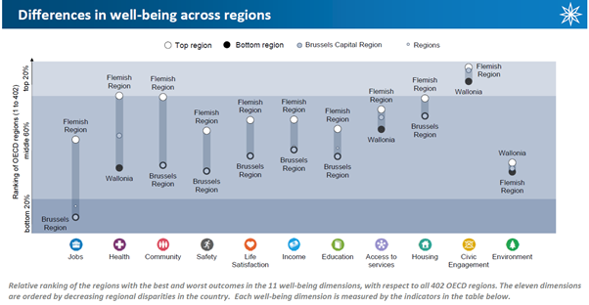
Brussels ranks in the top 20% of 327 OECD metropolitan areas in terms of GDP per capita. However, Belgian metropolitan areas have air pollution levels above the OECD median, as measured by the exposure of individuals to PM_{2.5}. The population of Liège enjoys better air quality than that of Ghent, Antwerp and Brussels.
Belgium uses different tools to promote sustainable businesses; for example, Flanders is a pioneer in developing voluntary agreements with industry, local authorities, NGOs and universities. Nevertheless, additional efforts and regulatory incentives are needed to further promote these businesses (frequency of inspections, certification of environmental management systems, sustainable public procurement).
Furthermore, it should be noted that in 2020, the Court of Auditors prepared a report on the implementation and monitoring of the SDGs in Belgium. Among its findings, the report highlights a lack of quantified targets to guide the pursuit of these SDGs.
Both the federal level and Wallonia have launched a study on the subject to this end. The aim is to prioritise the 169 targets and determine specific quantitative objectives where these do not yet exist.

Inspections
Lack of compliance with environmental legislation has decreased but remains a major concern to this day. The fight against non-compliance with environmental legislation varies from region to region. The OECD considers that Belgium could make greater use of administrative fines that do not require prior prosecution, and could step up the collection of financial penalties. The OECD also adds that the performance of law enforcement authorities could be improved by working on results indicators to influence behaviour.

Environmental governance

Coordination of environmental policies
In Belgium, the regions are in charge of most environmental policies. The federal government is responsible for product regulation, protection of the marine environment and parts of energy, transport and taxation, as well as the coordination of Belgium's international environmental policy. The regions work with the provinces and municipalities, which share responsibility for land use planning, the issuing of permits and environmental services.
The OECD notes that, despite unified European regulations, institutional and procedural practices may vary from one region to another. However, the reviewers add that this disparity is partly mitigated by coordination and advise Belgium to increase the effectiveness of coordination between the federal government and the regions, as well as between the regions themselves, particularly in the areas of climate change, water management, waste management and the circular economy.

Governance
Belgium uses a number of international good practices relating to policy assessment, the issuing of permits, compliance monitoring, and damage compensation. It has made progress on all the governance recommendations made in 2007.
In addition, the OECD recommends that Belgium reduce the public burden of environmental remediation by ensuring that landowners or other responsible parties clean up polluted sites directly, or pay a fee in order to build up public resources for remediation.
Strategic Environmental Assessment (SEA) has been increasingly used over the past decade. It is used for all land use plans, strategic plans and programmes with a potentially significant impact on the environment. However, Regulatory Impact Analysis (RIA) is only mandatory at federal level. Nevertheless, the OECD notes that several draft regional laws and regulations call for more extensive assessments. Environmental permits are fully integrated into urban planning in Flanders and Wallonia and are closely linked to the Environmental Impact Assessment (EIA) in each region.
The OECD also notes that public participation is an integral part of the EIA, SEA and permit-granting processes. The public is widely consulted on draft legislation, plans and programmes at all administrative levels.

Access to information and justice in environmental matters
The federal and regional authorities implement public policies and active publicity policies with mechanisms for public participation and access to environmental information. The public also has unfettered access to environmental information. The Belgian authorities regularly publish reports on the environment and sustainable development. The French, Flemish and German-speaking communities, which are responsible for education policies, work closely with the regions. The latter actively support environmental awareness (awareness centres, events, volunteer activities).
The comparability of data between regions has improved, especially for land-related data. Belgium has one of the highest percentages of developed land among OECD countries and land fragmentation has increased. The OECD therefore establishes that a close link between environmental law and land use planning law is important for integrating environmental aspects into land use planning.
Citizens' access to justice is guaranteed, but court proceedings can be lengthy and legal costs are high. The reviewers therefore call for a system of legal and financial assistance to support citizens in their procedures.

